The Solid Truth about States of Matter with Max Axiom Name: ________________________
Practice your reading comprehension skills (Bolded) using non-fiction science text. Reading for supporting facts and details helps you understand important science ideas.
Section 1 – Matter, Atoms, and Molecules
- Vocabulary: Everything you see around you is made of Matter. Find 5 examples of matter on pages 4-5.
___________________ ____________________ __________________ _________________ _________________
2. Use context clues on pages 6-7 to define matter. ________________________________________________________
3. Draw a Venn diagram below to compare and contrast weight and mass.
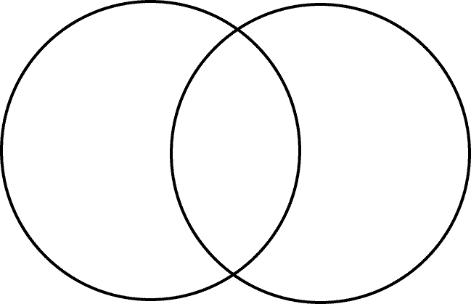
Weight Mass

4. Use context clues on pages 8-9 to define atoms. ________________________________________________________ __________________________________________________________________________________________________
Section 2 – Solids, Liquids, and Gases
5. List the three common states of matter. ___________________ __________________ ___________________
6. Another form of matter called plasma also exists. What causes plasma to form? _______________________________ __________________________________________________________________________
7. Why is changing a solid’s shape difficult? ______________________________________________________________
8. What causes the change of state from a solid to a flowing liquid? __________________________________________ __________________________________________________________________________________________________
9. Illustrate what molecules look like in a liquid and in a solid.

Section 3 - Melting, Boiling, and Freezing
10. Use context clues on pg.16 to define melting point. ____________________________________________________
11. What causes molecules to slow down? _______________________________________________________________
12. The process where molecules start clumping together again and reform a solid is called _______________________.
13. What is the effect of heating a liquid until the molecules start to fly apart? __________________________________
14. The _____________of a solid and a liquid always stay the same. A ______________ keeps its shape. A ___________ will flow to settle in the bottom of a container. A _______________ has no set shape or volume.
Section 4 – Evaporation and Condensation
15. Summarize the process of evaporation. ______________________________________________________________
__________________________________________________________________________________________________
16. Summarize how water vapor condenses into dew.______________________________________________________ __________________________________________________________________________________________________
17. Infer how the water cycle is related to states of matter. __________________________________________________ __________________________________________________________________________________________________
18. Questioning: Create a question or two you have now based off the reading. _________________________________ __________________________________________________________________________________________________
19. Main Idea: What was the main idea of this book? ______________________________________________________ ____________________________________________________________________________________________________________________________________________________________________________________________________
Bill Nye: Phases of Matter
- Everything you can touch is made of __________________________ .
- The difference between molten steel and solid steel is ______________________.
- List the three main phases of matter: _________________, ___________________, ________________
- The atoms in a solid move more ____________________________ than in a liquid.
- Matter can change phases by changing the amount of __________________________ .
- Water vapor is an example of a(n) __________________________ .
- Circle One: Energy does / does not change the phase of matter.
- Absolute Zero is when ____________ stop moving.
- You can use __________________________ to change a liquid into a gas.
- A gas and a(n) ________________________ will take the shape of a container.
- The _______________ and ______________ of molecules will make objects change their phase of matter.
- Circle One: To change a gas to a liquid, you need to increase / decrease the amount of heat energy.
- Circle One: To change a solid to a liquid, you need to increase / decrease the amount of heat energy.
- Changing a solid to a liquid to a gas is changing the _________________.

