- _______________________________: is a wave that vibrates particles of matter
- ________________________________: a rapid back and forth movement
- Sound is a ____________________ wave meaning _______________________________________________
- Is there sound in space? _______ because ______________________________________________________
- _____________________________ and__________________________________ effects the speed of sound
- Speed of Sound in Different Mediums: In order for particles to vibrate in a wave, one particle must then __________ the next particle to pass on the _______________ and continue the wave. Solids- _________________ Gases – ___________________
- Speed of Sound in Different Temperatures: Higher temp. – ______________ Lower temp. - ____________
- Amplitude/Intensity/Loudness: Amplitude determines intensity, which is just how ______/______ sound is.
High amplitude = ____________ intensity = ___________ energy = ____________
Low amplitude = _____________ intensity = ___________ energy =_____________
- Decibels (dB) = ____________________________________________________________________________
- Pitch: _____________________________________________; measured in ___________(waves per second)
Low frequency = ________ pitch; example: ______________________________________________________
High frequency = _________ pitch; example: _____________________________________________________
- Echo: ___________________________________________________________________________________
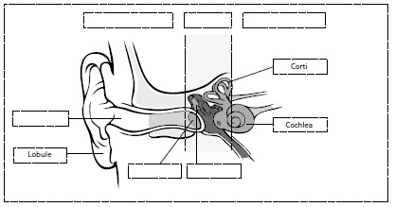
- Uses of Sound: ____________________________________________________________________________
Sound waves are sent. The ___________________ “catches the sound waves”. The _____________________ takes the sound waves and “_______________” the eardrum. The __________________ sends the messages to the brain and helps with balance. The _____________ puts it together to interpret what you are hearing.

