Earth, Sun, & Moon Lab Name________________________________________

Objective: In this lab, students will create situations where they can view moon phases, seasons, and the eclipses.
Questions: 1. Why does the moon seem to change shape? 2. Why do we experience lunar and solar eclipses?

Materials: Flashlight (the sun), Styrofoam ball on a pencil (the moon), and YOU! (the earth)
Procedure 1: Moon Phases - Each group member takes turns completing the following steps:
1. Place the Styrofoam ball on the pencil; this is going to represent the moon.
2. Hold the pencil with the white ball on it at arm's length in front of you and a little above your head.
3. Have one person hold a flashlight; this is going to represent the sun.
4. You represent the Earth. Slowly rotate on your axis, keeping the “moon” in front of you.
5. Watch as various parts of the white ball become lit and/or shaded.
6. Using the moon phase diagram in your data section, shade the circles to show the 8 phases of the moon. Use pg. E61 to guide you to accurately shade the phases.
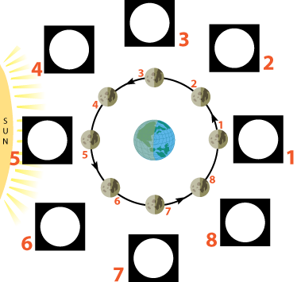
Write the name for each moon phase from your diagram.
1. _________________________________
2. _________________________________
3. _________________________________
4. _________________________________
5. _________________________________
6. _________________________________
7. _________________________________
8. _________________________________
Procedure 2: Eclipses - Each group member takes turns completing the following steps:
- As in the first activity, hold the ball out in front of you, but this time hold it level with your eye.
- Face the flashlight and hold the ball so that it blocks the light; you may need to adjust where you are standing until the moon fully blocks the light from the flashlight.
- What kind of eclipse are you modeling? Draw a sketch of the earth, moon and sun setup below. Include the shadow created from the eclipse. Identify the moon phase as well.
- Now face away from the flashlight and hold the ball so that the shadow of your head covers the ball.
- What kind of eclipse are you modeling? Draw a sketch of the earth, moon, and sun setup below. Include the shadow created from the eclipse. Identify the moon phase as well.

Solar Eclipse Moon Phase: ______________________

Lunar Eclipse Moon Phase: ______________________

Conclusion Questions:

Please answer the following conclusion questions:
1. What is a lunar cycle and how long does it take? ______________________________________________________ ________________________________________________________________________________________________
2. Why do we only ever see one side of the moon (the near side)? __________________________________________
________________________________________________________________________________________________
3. Does the moon light up at night? Explain the source of the light and why it appears to be lit.___________________ ________________________________________________________________________________________________________________________________________________________________________________________________________________________________________________________________________________________________
4. When there is a crescent moon, why does only a small portion of the moon appear in the sky?_________________
_______________________________________________________________________________________________________________________________________________________________________________________________
5. Explain why the moon appears to change shape. ______________________________________________________ ________________________________________________________________________________________________ ________________________________________________________________________________________________________________________________________________________________________________________________
6. What is the major difference between a lunar and a solar eclipse?________________________________________
________________________________________________________________________________________________________________________________________________________________________________________________
7. Why do we not experience a solar eclipse every month when the moon moves in front of the earth?
________________________________________________________________________________________________
________________________________________________________________________________________________

