EM Waves, Light, and Sound Test Review Answers Name: ________________________

Question | Answer
What do all waves transfer? | energy
Draw a wave and label these parts: crest, trough, wavelength, amplitude | 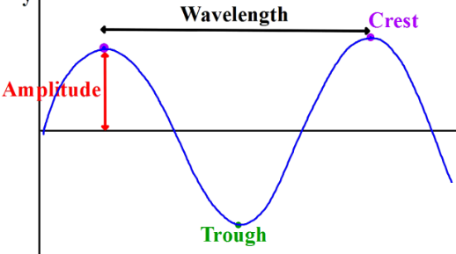
How is wavelength measured in a longitudinal wave? | two adjacent compressions or rarefactions
How are the waves on the electromagnetic spectrum arranged? | By lowest frequency/longest wavelength to highest frequency/shortest wavelength
List the electromagnetic spectrum in order from lowest frequency/longest wavelength to highest frequency/shortest wavelength? | Radio waves, microwaves, infrared, visible, ultraviolet, X-rays, and gamma-rays
How are electromagnetic waves different from each other? | Different frequency/wavelength
When visible light is absorbed by matter what happens to it? | It converts to thermal energy (heat)
How does color affect the absorption of visible light? | The darker the color, the more it absorbs
What part of the electromagnetic spectrum can be broken into seven colors? | Visible light
Name the color of visible light in order from shortest wavelength to longest wavelength. | ROYGBIV
When all seven colors of visible light are present, what color is the visible light? | white
How do we see specific colors of visible light? | The color we see is being reflected but the rest are being absorbed
What is the relationship between frequency and wavelength? | low frequency/long wavelength  highest frequency/shortest wavelength
How does a sound wave get started? | A vibration
What type of wave is a sound wave? | Longitudinal and mechanical
Through what state of matter do sound waves travel the fastest? Slowest? | Fastest – solid slowest - gas
What factors affect how fast sound waves travel? | Temperature, density/ state of matter/different mediums
How is the volume (loudness) of a sound changed? | Increasing intensity/amplitude
How is an echo produced? | It is a reflection of a sound wave; it bounces back
How does 265 Hz compare to 512 Hz? | 256 Hz would be a longer wavelength, lower pitch, lower frequency
How many decibels is the volume of normal conversation? | 60 hertz
At what decibel level can hearing be damaged? | 90 with long exposure
How are frequency and pitch related? | Higher frequency = higher pitch  lower frequency = lower pitch
Why is there no sound in space? | Sound is a mechanical wave; it needs a medium to travel through

