Ecosystems Notes
_______________________: the study of how living things interact in an environment.
_______________________: consists of the living things and their environment
_____________________: The living things in an ecosystem. Examples: ________________________________________
_____________________: The nonliving parts of an ecosystem. Examples: _____________________________________
Most energy transfer starts with the ____________________ (energy needed for photosynthesis)
________________________: Organisms that can make glucose during photosynthesis. They use most of the energy they make for themselves.
The energy that is not used by producers can be passed on to organisms that cannot make their own energy.
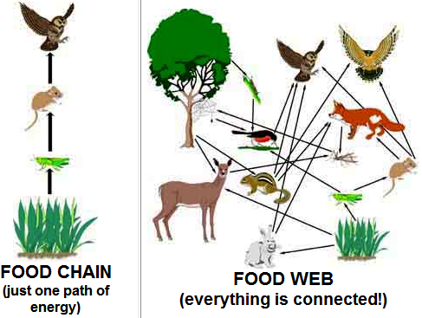
Organisms that cannot make their own energy are called ____________________________________.






