Earthquakes - Discovery Education Webquest Name:____________________
Earthquakes
- What causes earthquakes? _________________________________________________________________
- Why do most powerful earthquakes happen along boundaries between tectonic plates? ________________ ________________________________________________________________________________________
- Explain how an earthquake can cause a tsunami. ________________________________________________ ________________________________________________________________________________________
Science Lab: Earthquakes Click around and explore the page. Answer the following questions. Flip the switch at the top and see the effects that different magnitudes of earthquakes have. Don’t forget to click the book at the bottom of the screen for more information!
Question | Answer
How are earthquakes recorded?
How do scientists measure the size of the earthquake?

What are seismic waves?

What is the epicenter?

What is the focus?

Describe primary waves. Draw a picture.

Describe secondary waves. Draw a picture.

Describe surface waves. Draw a picture.

How it Shakes Out
- What are the characteristics of earthquakes occurring along divergent plate boundaries? ______________ _______________________________________________________________________________________
- What type of plate boundary produces earthquakes with the greatest focal depth? ___________________ _______________________________________________________________________________________
- Why do so many earthquakes occur along plate boundaries? _____________________________________ _______________________________________________________________________________________
Quake It, Don’t Shake It City Hall wants to be “earthquake proof”. The town has three options: 1) keep the current City Hall; 2) tear it down and build a new building on the same site; or 3) build a new building on a site with different underlying soil and rock. Record your testing data in the chart below using the “experiment” section.
Trial # | Building Type | Foundation | Ground Beneath Building | Earthquake Size | Results (describe damage to building)
1
2
3
4
5
What do you suggest for the City Hall building?

Latest Earthquakes https://earthquake.usgs.gov/earthquakes/map/ On the left side you will see a list of the latest earthquakes in the world that have a 2.5 magnitude or higher. Answer the following questions:
Question | Answer
How many earthquakes have occurred around the world TODAY?
Where in the world have the most earthquakes occurred TODAY? (use the “zoom to menu)
Where was the most recent earthquake in the United States?
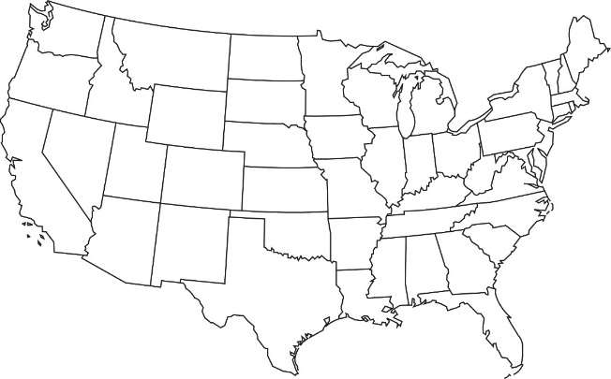
Using the USGS website, mark all of the earthquakes that occurred in the United States TODAY with a colored circle.

