Name: ________ Class: __________ Date: ______
Analyzing a Histogram

SALARIES
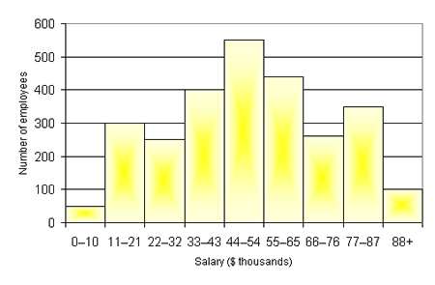
Answer each question below using the histogram. Assume that each bar that is not on a multiple of 100 is in the middle.

- How many employees have a salary of $33-43 thousand dollars?

- How many employees make $55 thousand dollars or more?

- How many employees make between $33 and $76 thousand dollars?

- In what interval would the median salary fall?

- What percent of all the employees make less than $33 thousand dollars?

Analyzing a Histogram- SOLUTIONS

SALARIES
Answer each question below using the histogram. Assume that each bar that is not on a multiple of 100 is in the middle.
- How many employees have a salary of $33-43 thousand dollars?
400 Employees
- How many employees make $55 thousand dollars or more?
450 + 250 + 350 + 100 = 1,150 Employees
- How many employees make between $33 and $76 thousand dollars?
400 + 550 + 450 + 250 = 1,650 Employees
- In what interval would the median salary fall?
There are 2,700 total employees, so that median employee is around 1,350. This employee would fall in the 44 – 54 interval.
- What percent of all the employees make less than $33 thousand dollars?
Total Employees = 2,700. 600 make less than $33 thousand. 600/2,700= 22.2%

