Box Plots

Use the data below to find the five-number summary, draw the box and whisker plot, and answer the following questions.

6, 8, 2, 40, 22, 4, 17, 12, 26, 11, 9, 24

Minimum: 2 Lower Quartile: 7 Median: 11.5 Upper Quartile: 23 Maximum: 40

**Have students list the specific data numbers in between each part of the 5-number summary. This is important to get students to understand that 25% of the data (4 out of the total 12 pieces of data) lies between each number of the 5-number summary, but that the spread of the box-and-whisker plot is created by the range of the data in each part.

24

26

40

12

17

22

8

9

11

2

4

6

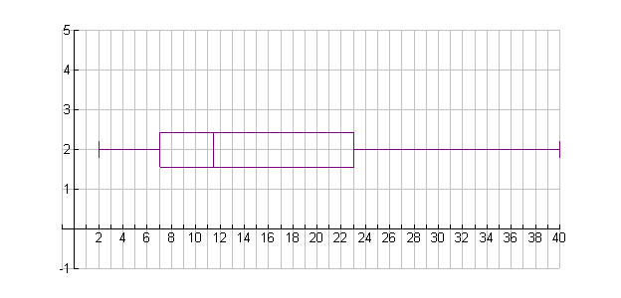



What is the line in the middle of the box?

The Median

What is the range of the data values?

40 -2 = 38

How many pieces of the data lie within each 25%?

1. Between 2 and 7? 3 b.) Between 7 and 11.5? 3
2. Between 11.5 and 23? 3 d.) Between 23 and 40? 3

What percent of the data lies between:

|  |  |
| --- | --- |
| a.) 2 and 7? 25% | e.) 2 and 11.5? 50% |
| b.) 7 and 11.5? 25% | f.) 7 and 23? 50% |
| c.) 11.5 and 23? 25% | g.) 7 and 40? 75% |
| d.) 23 and 40? 25% |  |

What is the range between:

The minimum and lower quartile? 5 The lower quartile and the median? 4.5

The median and the upper quartile? 11.5 The upper quartile and the maximum? 17

What do you think that the distance between the minimum and lower quartile is so different from the upper quartile and the maximum? The range in the data that lies in that part of the box-and-whisker plot is different.

What is the interquartile range (IQR)? 23 – 7 = 16