GCF and LCM Word Problems

- There are 14 girls and 21 boys in Mrs. Andrews’s gym class. To play a certain game, the students must form teams. Each team must have the same number of boys and girls. What is the greatest number of teams Mrs. Andrews can make if every student is on a team?

GCF and LCM Word Problems

- As 100 students entered the auditorium they were each given a prize. If every 6th student received a pencil and every 9th student received a notebook, how many participants received both a pencil and a notebook?

GCF and LCM Word Problems
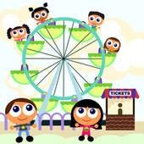

- Ralph and his brother are at a carnival. They separate from each other at the ferris wheel at 1:00 PM, and they agree that they will each meet back at the ferris wheel from time to time to see whether the other is ready to leave. Ralph checks the ferris wheel every 10 minutes. Joe checks in every 12 minutes. At what time will they meet at the ferris wheel again. (Hint: Don’t forget you’re looking for a time.)

GCF and LCM Word Problems
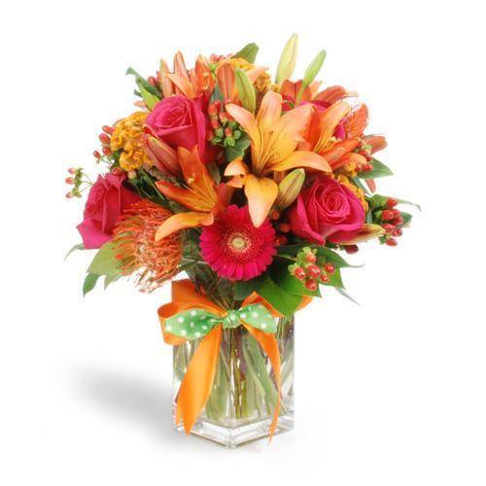

- Mrs. Lovejoy makes flower arrangements. She has 36 red carnations and 72 pink carnations. Each arrangement must have the same number of each color. What is the greatest number of arrangements she can make if she uses every carnation?

GCF and LCM Word Problems

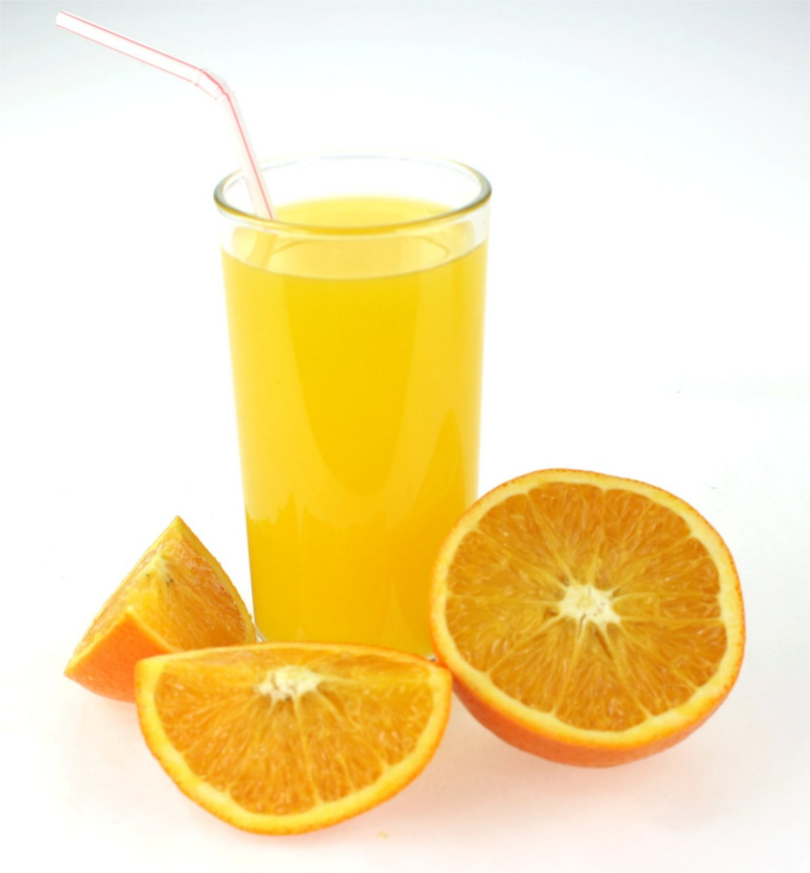
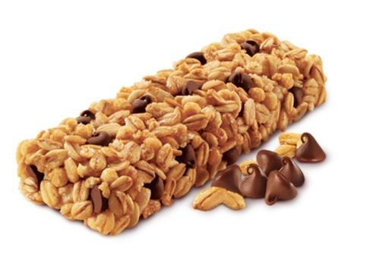

- Juice comes in packs of 6 and granola bars come in packs of 8. If there are 24 players on the soccer team, what is the least number of packs needed so that each player has a drink and granola bar and there are none left over? (Hint: You will have 2 answers)

GCF and LCM Word Problems
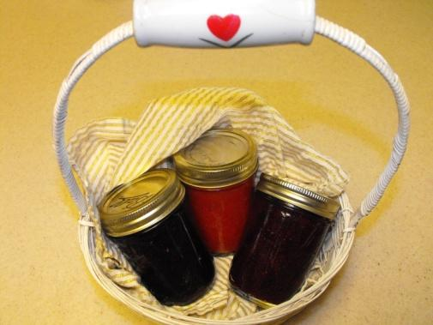

- Vincent has 16 jars of strawberry jam and 24 jars of raspberry jam. He wants to place the jam into the greatest possible number of boxes so that each box has the same number of jars of each kind of jam. How many boxes does he need?

GCF and LCM Word Problems
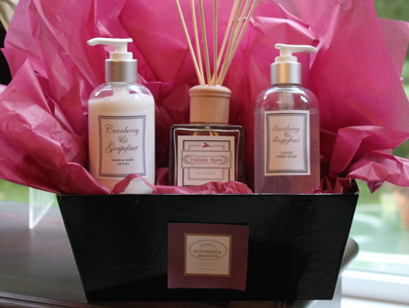

- Carolyn has 36 tubes of hand lotion and 60 bars of lavender soap to make gift baskets. She wants to have the same number of each item in every basket. What is the greatest number of baskets she can make without having any of the items leftover?

GCF and LCM Word Problems

- Two faucets are dripping. One faucet drips every 4 seconds and the other faucet drips every 9 seconds. If a drop of water falls from both faucets at the same time, how many seconds will it be before you see the faucets drip at the same time again?

GCF and LCM Word Problems

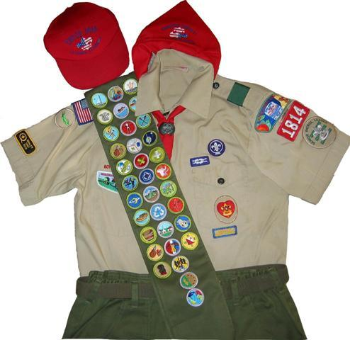

- Mr. Stevenson is ordering shirts and hats for his Boy Scout Troop. There are 60 scouts in the troop. Hats come in packs of 3, and shirts come in packs of 5. What is the least number of packs each he should order so that each scout will have 1 hat and 1 shirt, and none will be left over?

GCF and LCM Word Problems
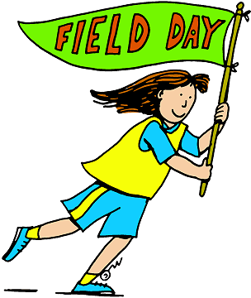

- Mr. Thompson’s class was competing in field day. There were 16 boys and 12 girls in his class. He divided the class into the greatest number of teams possible with the same number of boys and girls on each team. How many teams were made if each person was on a team? How many girls were on each team? How many boys were on each team?

GCF and LCM Word Problems
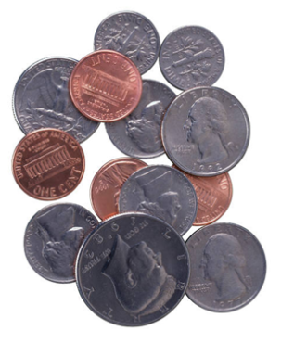

- Josie has 15 quarters and 45 nickels. He wants to group the money so that each group has the same number of each coin. What is the greatest number of groups he can make? How many of each coin will be in the group? How much money will each group be worth?

GCF and LCM Word Problems
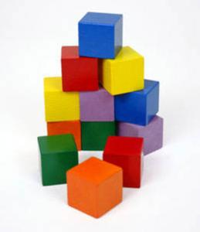

- Two students in Mrs. Abal’s preschool class are stacking blocks, one on top of the other. Reece’s blocks are 6 cm high, and Maddy’s blocks are 10 cm high. How tall will their stacks be when they are the same height for the first time?

Name _______________________ Date _________________

GCF and LCM Word Problem Answer Sheet

1.)  _______ teams  Is this problem GCF or LCM? How do you know?  _____________________________________  _____________________________________ | 2.)  _______ participants received a pencil and notebook  Is this problem GCF or LCM? How do you know?  ________________________________________  ________________________________________
3.)  They will meet at ______  Is this problem GCF or LCM? How do you know?  _____________________________________  _____________________________________ | 4.)  ________ arrangements  Is this problem GCF or LCM? How do you know?  ________________________________________  ________________________________________
5.)  ______ packs of juice and _____ packs of granola bars  Is this problem GCF or LCM? How do you know?  ______________________________________  ______________________________________ | 6.)  _________ boxes  Is this problem GCF or LCM? How do you know?  ________________________________________  ________________________________________
7.)  ________ baskets  Is this problem GCF or LCM? How do you know?  _____________________________________  _____________________________________ | 8.)  _________ seconds  Is this problem GCF or LCM? How do you know?  ________________________________________  ________________________________________
9.)  ________ packs of hats and _________ packs of shirts  Is this problem GCF or LCM? How do you know?  ______________________________________  ______________________________________ | 10.)  _________ Teams _________ Girls _________ Boys  Is this problem GCF or LCM? How do you know?  ________________________________________  ________________________________________
11.)  ______ Groups  ______ quarters and ______nickels in each group  Each group is worth ___________  Is this problem GCF or LCM? How do you know?  ____________________________________  ___________________________________ | 12.)  __________cm  Is this problem GCF or LCM? How do you know?  ________________________________________  ________________________________________

